Starbucks Offer Analysis:

Tailoring Offers to Customers

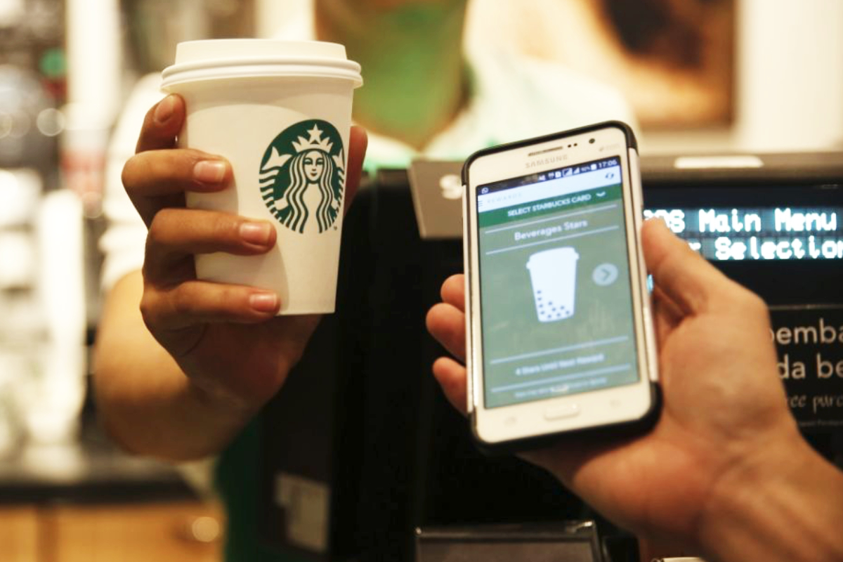

Source: https://www.foodbusinessnews.net/articles/14160-starbucks-takes-stake-in-restaurant-tech-company

Starbucks’ loyalty program that is the envy of the retail food industry. The program’s approximately 16 million active members contribute roughly 40% of the company’s sales[1]. This allows for data processing of transactions and subsequent tailoring of offers to optimize for a variety of factors.

As part of the Udacity Data Science Nanodegree, Starbucks provided synthetic data that emulated a simplified product offerings and transactions by various customers. The goal that I set was to establish a model that would predict the impact by any offer (current and future) on any individual given the attributes of the offer and person.

# Data Used

Three datasets were provided:

## Portfolio

An overview of the various promotional offers. Attributes included channel (mobile, social, email) and offer type (bogo, discount, informational). A measure of difficulty, reward and duration were also provided.

## Profile

Customer attributes; age, income, gender, member join date. Though there were some gaps in this data (~12% missing), there was sufficient info for imputing the missing information. Distributions of some attributes are shown below.

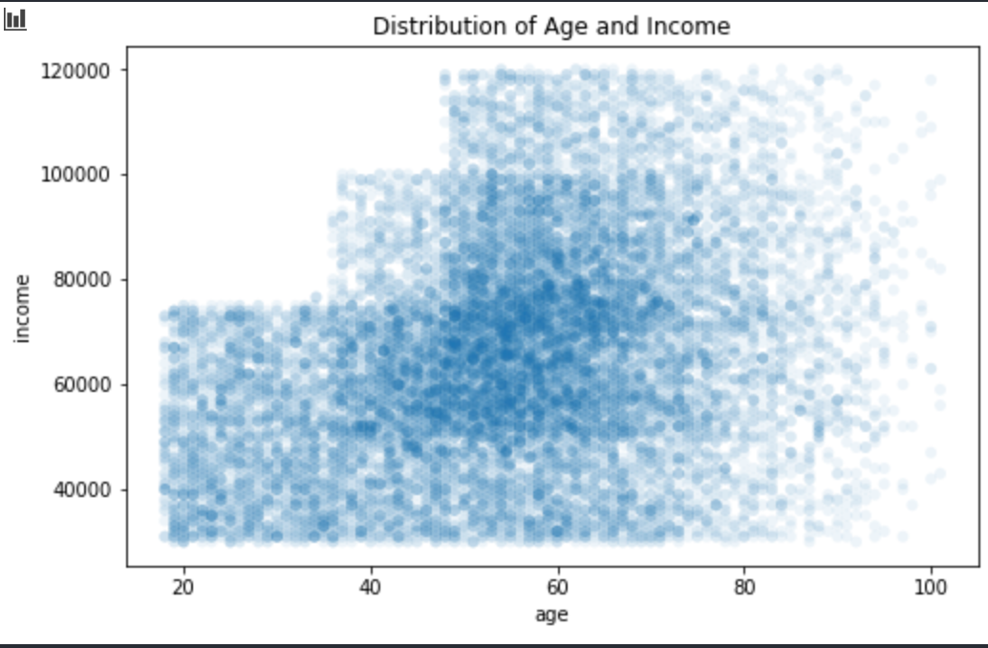 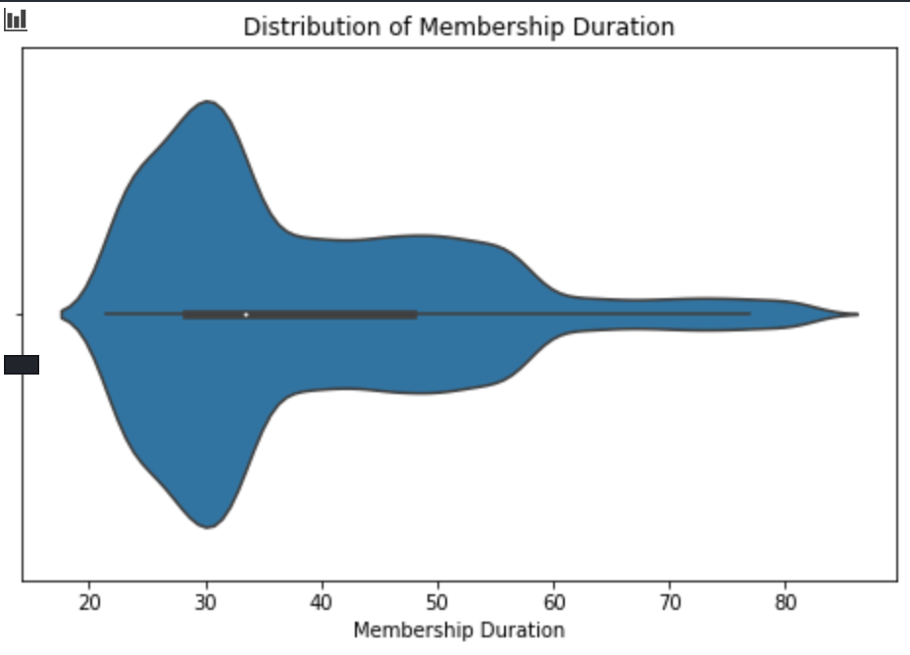

## Transcript

A dated log of transactions as well as offers being sent, viewed and completed. There was significant cleaning and processing to convert this data into a useable format.

Below is an overview of the transactions along with the date received. You can see that offers are sent at specific times (shown in blue).

# 

# Workflow

The transaction data was processed to determine if which transactions were influenced by an offer (had to be viewed, not completed, and within duration). From this, a dataset of every customer-offer pairing was established, along with the resultant daily spend relative to the non-influenced spend.

The lift impact of these offers were then merged with the attributes from the offer portfolio, as well as the customer profile information. After some outlier processing, sample results shown below, this dataset was used to train the models.

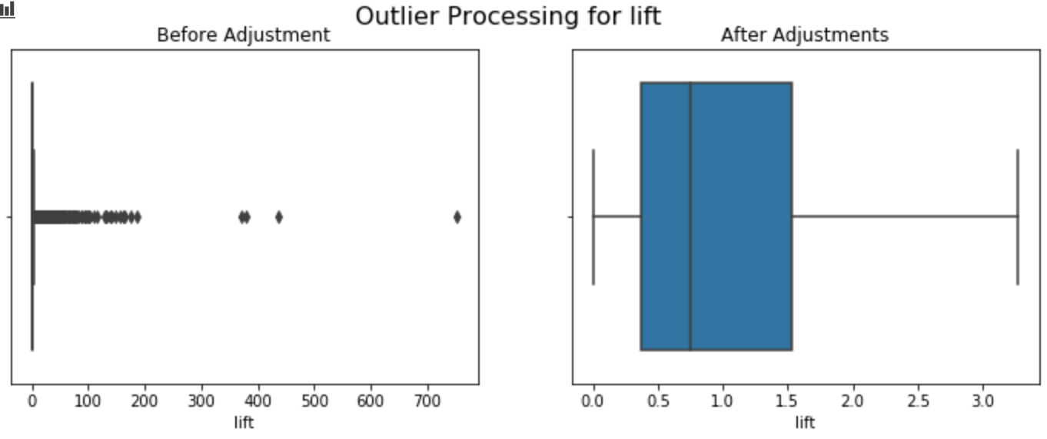

# Models

I chose not to use FunkSVD or another recommender algorithm as I wanted one model that would predict the resulting impact – amalgamating the feature importance of all inputs into one item. Working with these models will allow for better understanding of how to tailor future offers to engage particular types of people.

Though there were multiple efforts to get a regression model to provide the actual Lift (increase in spending during offer), the limited time remaining on my Udacity account prompted me to complete this project for submission. This would be an area of interest for further development.

A target variable was established – indicating whether or not the Lift was over a particular threshold. In the default case, 1.25 was used. XGBoost Classification and Logistic Regression models were trained and stored on the dataset.

## Insights from Models

Beyond the future potential use of these models for predicting the impact of future tailored promotions, some insights can be extracted to feed into that process. From the XGBClassifier, feature importance was established (see below).

It can be seen that a customer’s daily spending habits have the largest impact on this model, followed by the size of the reward. Income is less important to the model result than I anticipated. For promotional offers (bogo, or discount), it seems as though it less important which type of offer is made.

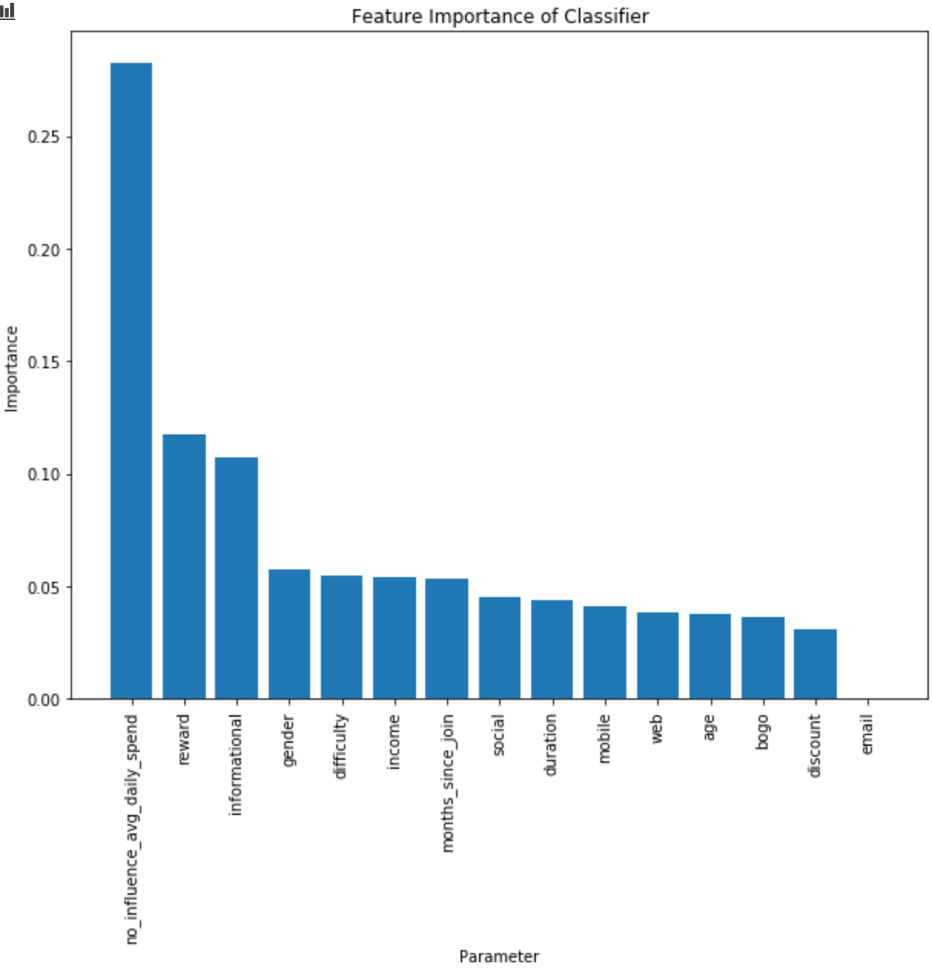

In an effort to establish which way these attributes drive the result, the log-odds were extracted from the logistic regression coefficients. From the below, it’s shown that the higher a customer’s regular spending, the less likely they will be impacted by a an offer. Also, longevity is a positive indicator of the impact on offer success. Informational offers also seem to drive higher spending than bogo or discount offers – which could be due to the discount itself suppressing their average purchase.

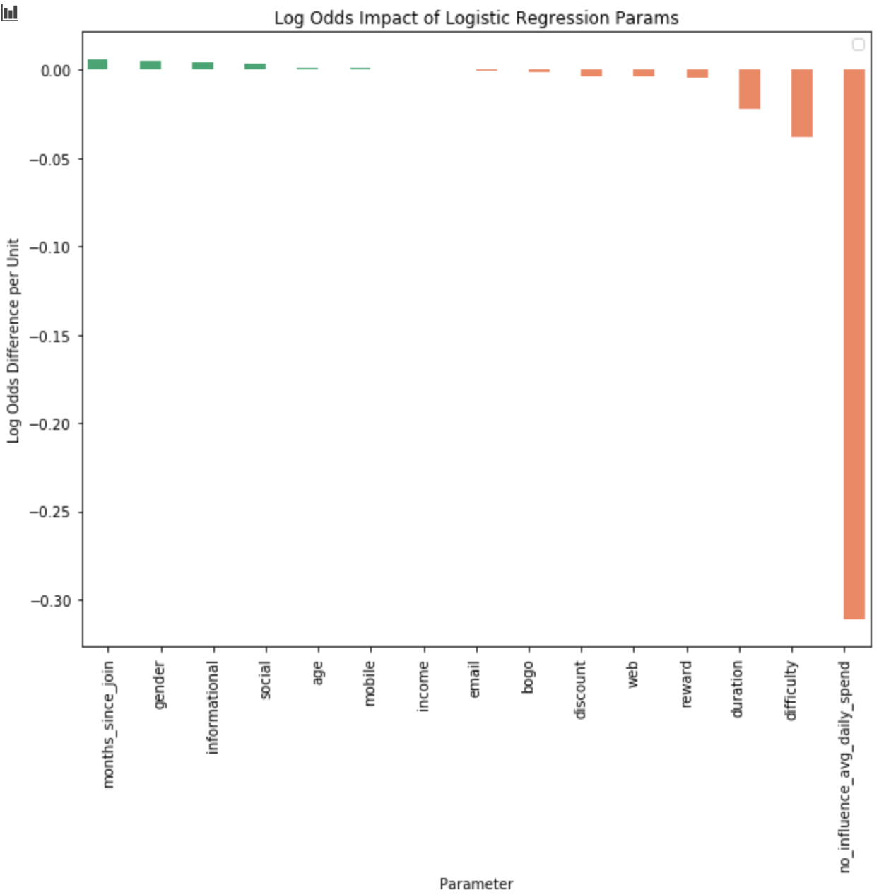

1. https://digital.hbs.edu/platform-digit/submission/starbucks-winning-on-rewards-loyalty-and-data/